

# CS 305 Project Two

**Practices for Secure Software Report**

Table of Contents

_Toc33111301

Document Revision History 3

Client 3

Instructions 3

Developer 4

1. Algorithm Cipher 4

2. Certificate Generation 4

3. Deploy Cipher 4

4. Secure Communications 4

5. Secondary Testing 4

6. Functional Testing 5

7. Summary 5

## Document Revision History

| **Version** | **Date** | **Author** | **Comments** |
| --- | --- | --- | --- |
| **1.0** | **6/19/22** | **Michael Martin** |  |

## Client



## Instructions

Deliver this completed Practices for Secure Software Report documenting your process for writing secure communications and refactoring code that complies with software security testing protocols.

Respond to the steps outlined below and replace the bracketed text with your findings in your own words. If you choose to include images or supporting materials, be sure to insert them throughout.

## Developer

Michael Martin

## 1. Algorithm Cipher

Determine an appropriate encryption algorithm cipher to deploy given the security vulnerabilities, justifying your reasoning. Be sure to address the following:

* Provide a brief, high-level overview of the encryption algorithm cipher.
* Discuss the hash functions and bit levels of the cipher.
* Explain the use of random numbers, symmetric vs non-symmetric keys, and so on.
* Describe the history and current state of encryption algorithms.

Artemis Financial is seeking to add file verification to their web application to ensure secure communications. I chose to use SHA-256 as the cipher algorithm for a few reasons. First, it allows for Asymmetric communication, which means that the encryption key is public, while the decryption key is private. Second reason is the bit length, 256 bits are used to encrypt any data being sent using the public key. In short this creates 2^256 possible combinations per bit, which would be impossible to brute force. This cypher meets the requirements of Artemis Financial.

## 2. Certificate Generation

Generate appropriate self-signed certificates using the Java Keytool, which is used through the command line.

* To demonstrate that the keys were effectively generated, export your certificates (CER file) and submit a screenshot of the CER file below.

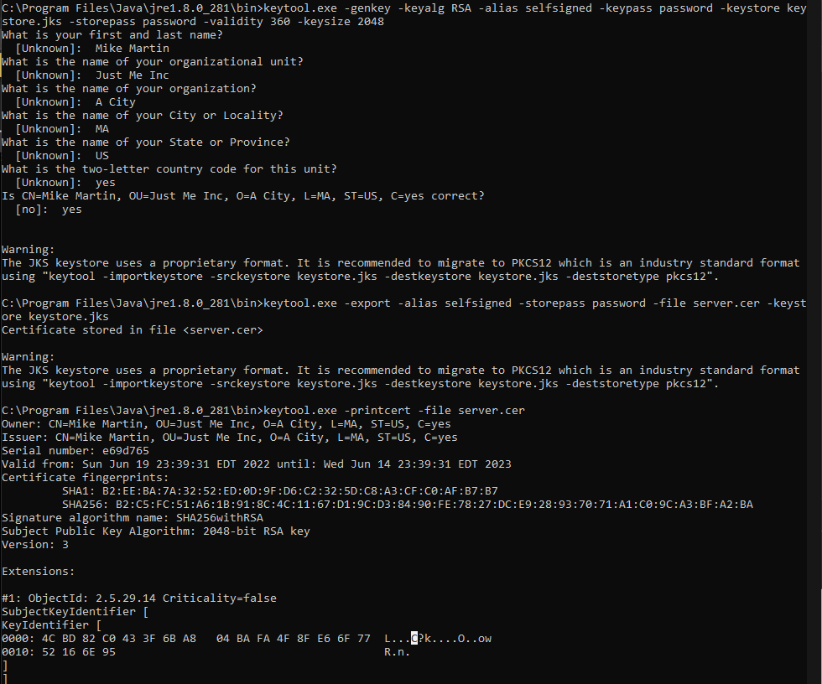

## 3. Deploy Cipher

Refactor the code and use security libraries to deploy and implement the encryption algorithm cipher to the software application. Verify this additional functionality with a checksum.

* Insert a screenshot below of the checksum verification. The screenshot must show your name and a unique data string that has been created.



## 4. Secure Communications

Refactor the code to convert HTTP to the HTTPS protocol. Compile and run the refactored code to verify secure communication by typing **https://localhost:8443/hash** in a new browser window to demonstrate that the secure communication works successfully.

* Insert a screenshot below of the web browser that shows a secure webpage.

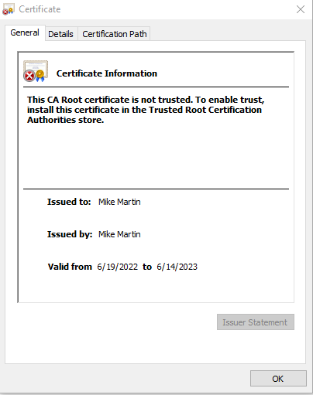



*Please note that this error is caused by the cert not being installed to the local CA, and therefore not trust by nature due to being self-signed.*

## 5. Secondary Testing

Complete a secondary static testing of the refactored code using the dependency check tool to ensure code complies with software security enhancements. You only need to focus on the code you have added as part of the refactoring. Complete the dependency check and review the output to ensure you did not introduce additional security vulnerabilities.

* Include the following below:
  + A screenshot of the refactored code executed without errors
  + A screenshot of the dependency check report

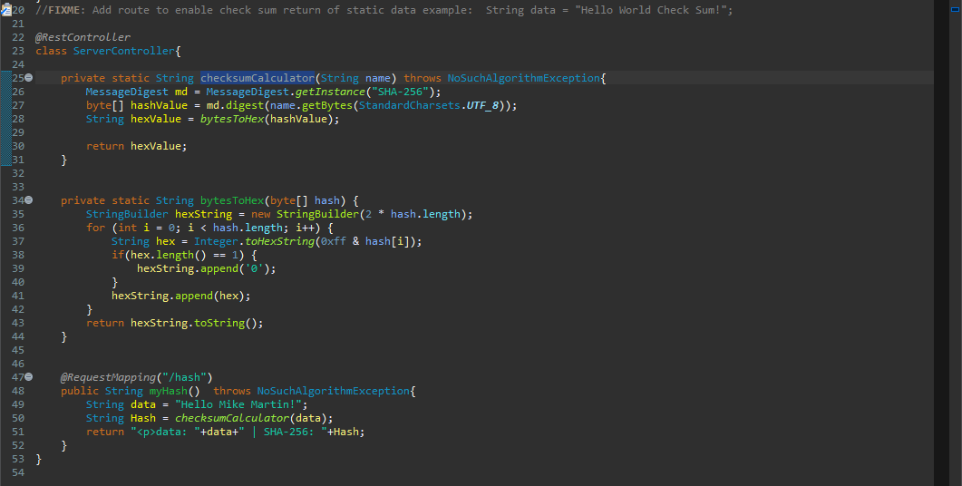

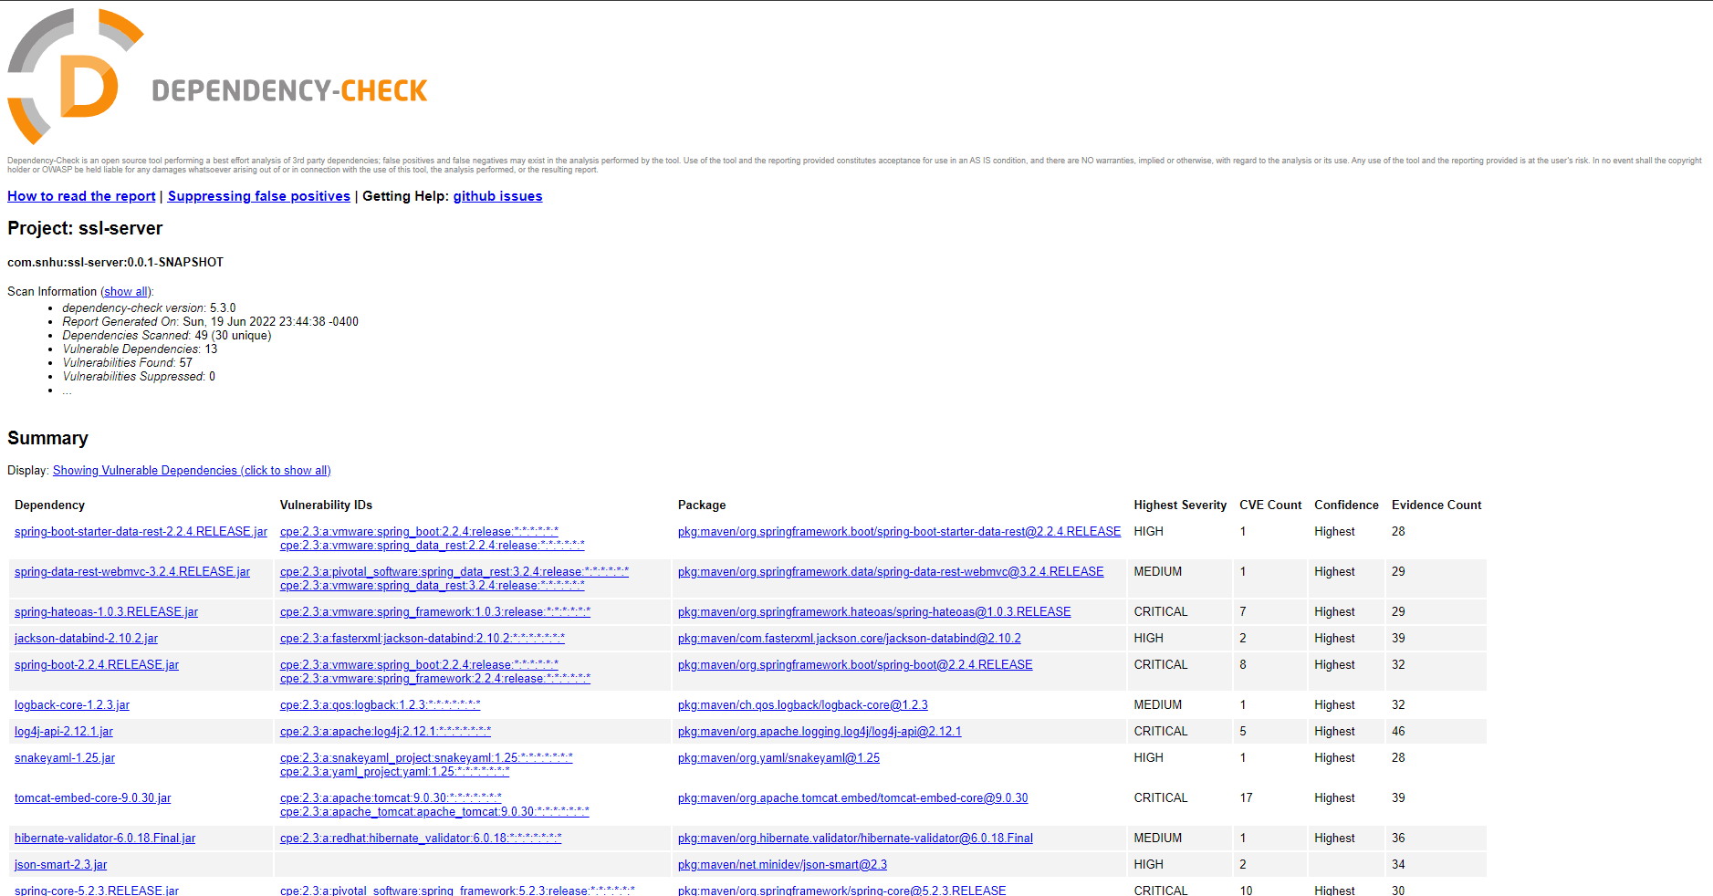

## 6. Functional Testing

Identify syntactical, logical, and security vulnerabilities for the software application by manually reviewing code.

* Complete this functional testing and include a screenshot below of the refactored code executed without errors.

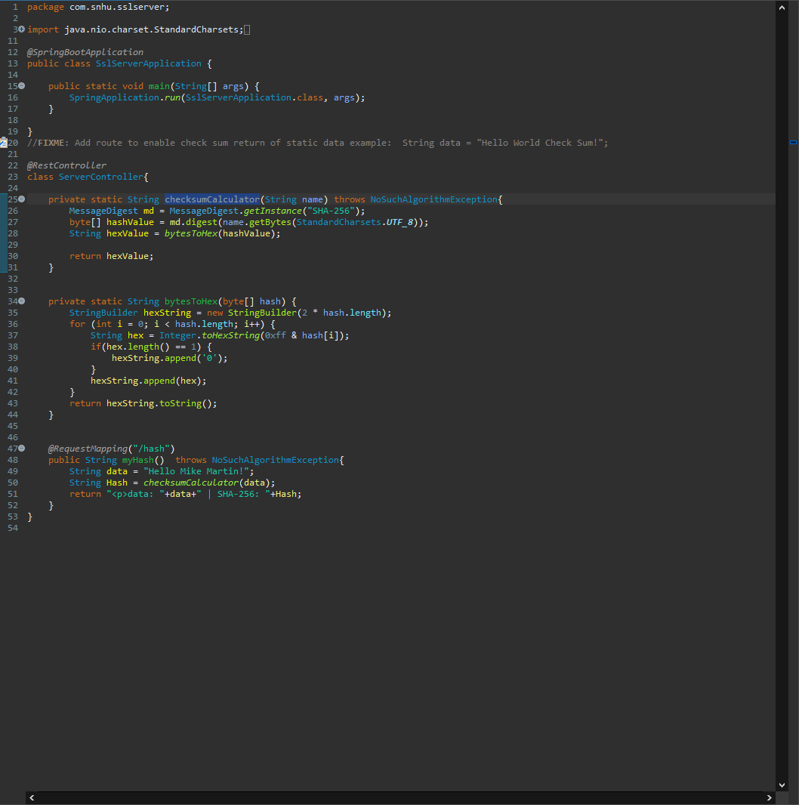

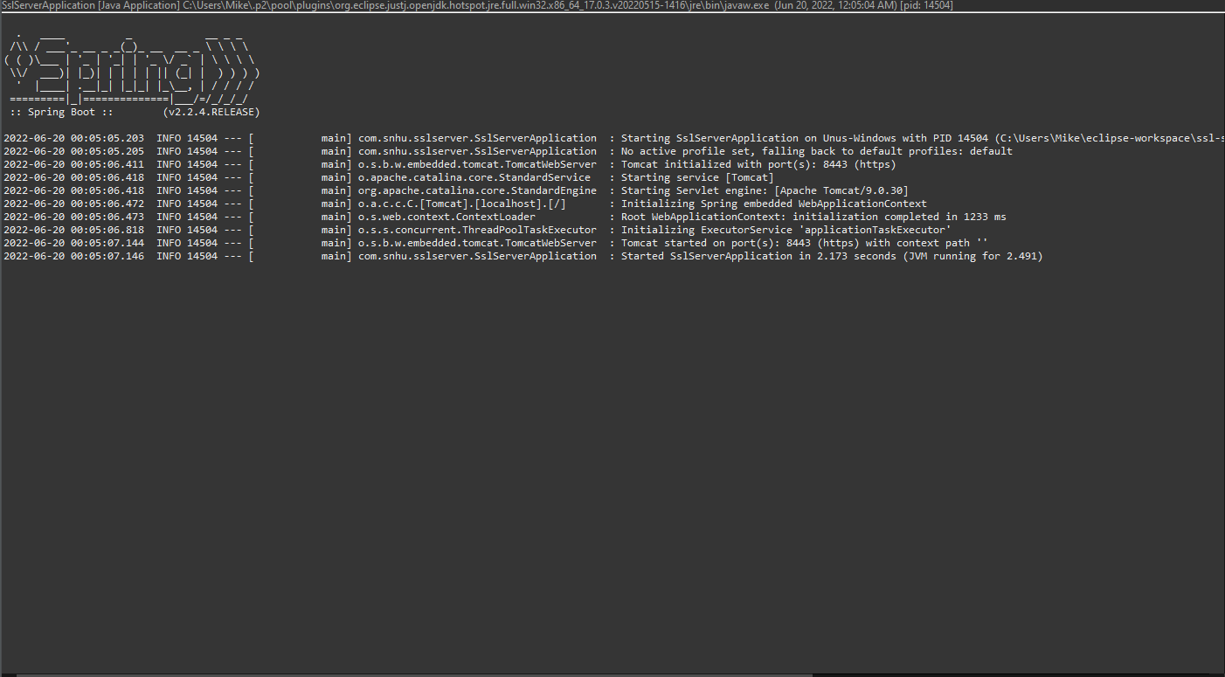

## 7. Summary

Discuss how the code has been refactored and how it complies with security testing protocols. Be sure to address the following:

* Refer to the Vulnerability Assessment Process Flow Diagram and highlight the areas of security that you addressed by refactoring the code.
* Discuss your process for adding layers of security to the software application and the value that security adds to the company’s overall wellbeing.
* Point out best practices for maintaining the current security of the software application to your customer.

While refactoring my code I didn’t feel much change was needed. The code I provided previously was based on best practices. What I did change was the access modifier of method “checksumCalculator” to private, previously it was public.

The software helps secure communications on their website by implementing SHA-256 cypher. This cypher is extremely secure, as it has yet to be cracked. The cypher also has a small chance of collisions due to the way the hash algorithm works.

I recommend running the vulnerability checker every month or so to ensure that the software has no major vulnerabilities. I also recommend to keep using the newest dependencies as it ensures that anything new vulnerabilities have been patched.